Camera and Rental Store Website User Guide.

USE THE LINK HOSTED AND LIVE:

<https://camerarentals.store/>

FOR ADMIN:

<https://camerarentals.store/admin>

**Contents**

1. Introduction
2. Registration/Login

2.1. User

2.1.1. Dashboard

2.1.2. Booking

2.1.3. Transaction

2.1.4. Visit frontend

2.2. Vendor

2.1.1. Dashboard

2.1.2. Services

2.1.2. Booking

2.1.3. Transaction

1. Vendors
2. Searching
3. Search by category

**Introduction**

Variety of camera-related services, such as camera rentals, cameramen, and album designing, are offered online at Camera Rental Store. We made this services available online so that customers could save time by avoiding trips to offline stores.

**Homepage**

A website's homepage is the first page to load and contains all the options, such as registration, login, vendors, category, etc log in and browse the services our website offers.

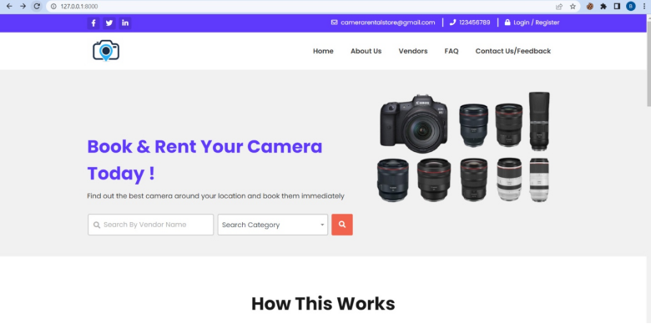

**Registration**

Click on the register if you are a new user choose the option if you want to register as a user or a vendor, this will take you to the registration page where you can enter your first name, last name, user name, email address, password and then submit this will create your account on the website.

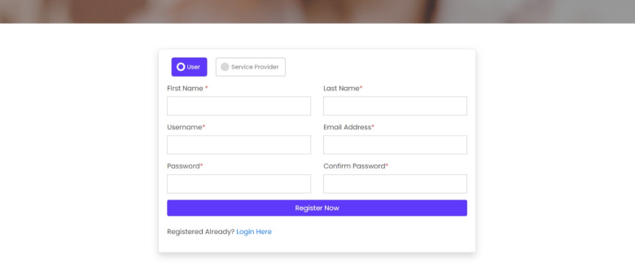

**Login**

If you already have an account and are a registered user, clicking the login button will take you to the user or vendor dashboard, depending on your signup preferences.

2.1. User

2.1.1. Dashboard: The dashboard shows you all the details about your bookings, transactions and profile. The three options are given at the left which give all the information of your account.

2.1.2. Booking: This options shows the details about the booking you made.

2.1.3. Transactions: This options shows all the transaction details you make.

2.1.4. Visit frontend: This will take you to the main homepage.

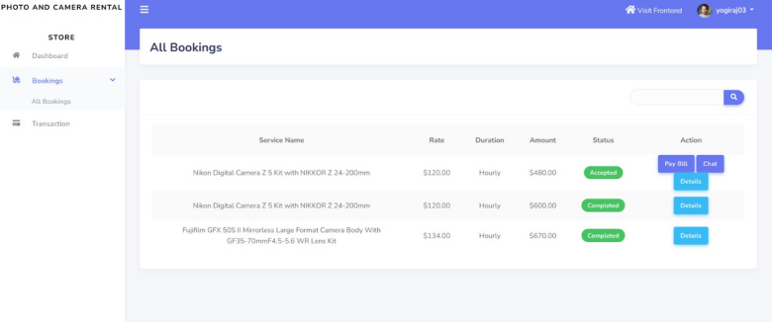

2.2. Vendor

2.2.1. Dashboard: You can browse through this dashboard to get the idea about how much orders you accepted, completed and how much you have earned.

2.2.2. Services: click on this option to add the services you want to offer then browse through the categories that you want to list on the website, then add price to the service in pricing tab , enter details , select available hours and submit request.

2.2.3. Booking: Browse through this tab so see which bookings are pending so you can accept the request from the user.

2.2.4. Transaction: This option shows you all the transactions records.

2.2.5. Booking details: This shows all the details about the bookings, pending transactions, name of the service, basically it is a record of the bookings you got.

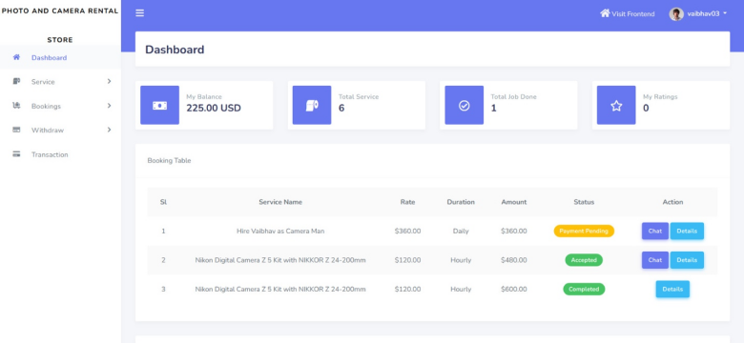

**Vendors**

To see the available vendors and services click on this option and this select the vendor and see the services offered by the vendor and select the service you want click book now option to book the service.

Vendors > select from available list of vendors > select the service > book now

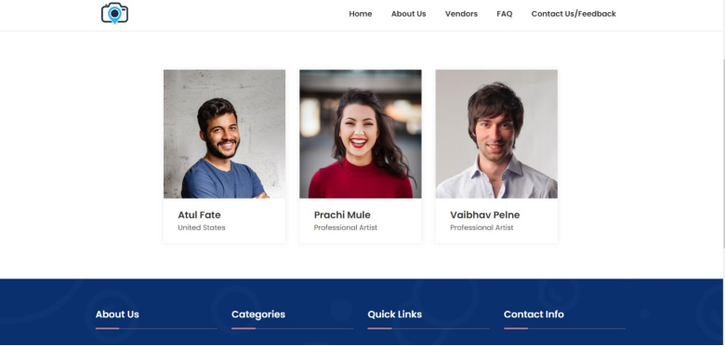

**Searching**

Search by vendor, search category: you can even look for particular service and vendor by using names in search this box.

**Payments**

After booking the service there will be a checkout button on clicking the checkout page you will be directed to the payment page where you can select manual payment or PayPal.

Manual bank payment: All the bank details such as bank name, branch, and account number are given so you can enter these details in your bank app or pay the amount directly from the bank and then upload the transaction number and proof of payment. The payment proof should be in the JPEG format.

PayPal: This is the other payment option you can do this payment just by entering details asked by the PayPal website such as name, card number, CVV, expiry date, email.

Contactus/Feed back

From this page you can contact us regarding any issue, suggestion and anything and the same time give us feedback for any improvements.